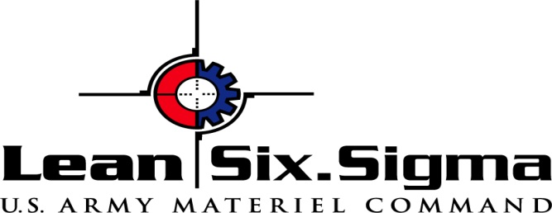­­­

**DMADV** is used to create new product or process designs through:

* **Define** design goals that are consistent with customer demands and the enterprise strategy.
* **Measure** and identify CTQs (characteristics that are Critical to Quality), product capabilities, production process capability, and risks.
* **Analyze** to develop and design alternatives, create a high-level design and evaluate design capability to select the best design.
* **Design** details, optimize the design, and plan for design verification. This phase may require simulations.
* **Verify** the design, set up pilot runs, implement the production process and hand it over to the process owners.

**Six-Sigma Methodology**

Six-Sigma has two key methodologies, which are **DMAIC and DMADV**, both inspired by Deming's Plan-Do-Check-Act Cycle.

**DMAIC** is used to improve an existing business process using five elements:

* Define process improvement goals that are consistent with customer demands and the enterprise strategy.
* Measure key aspects of the current process and collect relevant data.
* Analyze the data to verify cause-and-effect relationships. Determine what the relationships are, and attempt to ensure that all factors have been considered.
* Improve or optimize the process based upon data analysis using techniques like Design of Experiments.
* Control to ensure that any deviations from target are corrected before they result in defects. Set up pilot runs to establish process capability, move on to production, set up control mechanisms and continuously monitor the process.



***Total Quality Systems***

***Eastern Illinois University***

***School of Technology***

***December 2010***

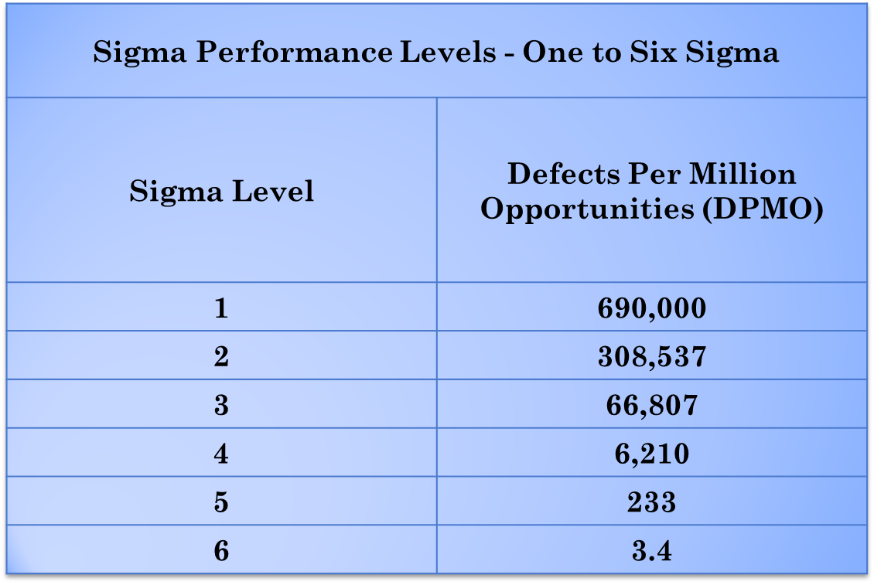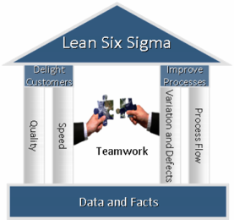

**Customization of processes and programs to suit specific organizational needs**

* Practical orientation to the professional environment with the advisory and consulting perspective
* Access to global practices to better understand and deploy methodologies
* Usage of project management frame work to effectively execute projects

**Why Use Lean Six Sigma?**

Implementing Lean

To successfully implement Lean Six Sigma, four key elements must be addressed:

1. **Delight the customer** by delivering higher quality service in less time
2. **Improve processes** by eliminating defects (anything that is unacceptable to the customer) and focuses on how work flows through the processes
3. Use **teamwork** and share ideas with each so problems are solved
4. Base all decisions on **data and facts**

Lean Six Sigma is a business improvement methodology which combines (as the name implies) tools from both Lean Manufacturing and Six Sigma. Lean manufacturing focuses on speed and traditional Six Sigma focuses on quality. By combining the two, the result is better quality faster.